Quinterac Front End System Documentation

CISC327 Fall 2019

Assignment 2

Instructor: Dr. Ding

Contributors:

Denny, Matt (16mmmd1)

Laxdal, Kai (16kibl)

Littlefield, Brent (16bml1)

Liu, Tong (9tl14)

# System Specifications

Please refer to <https://l1nna.com/327/Course%20Project.pdf> for functional specifications of the Quinterac Front End System (QFES).

Qualitative requirements are not considered to be within the scope of this assignment.

# System Design

## General Front Design

The following diagram summarizes the inputs and outputs of QFES.

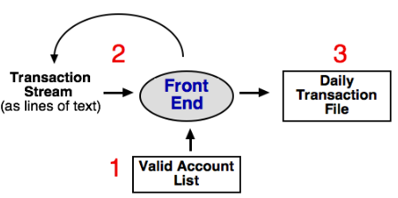

## Class Hierarchy Diagrams

The current implementation of QFES is the first of a series of evolutionary prototypes. The prototype has been simplified in terms of several lower-level details for ease of development and testing. The following class diagrams describe the intended design and architecture of QFES.

FrontEndObject:

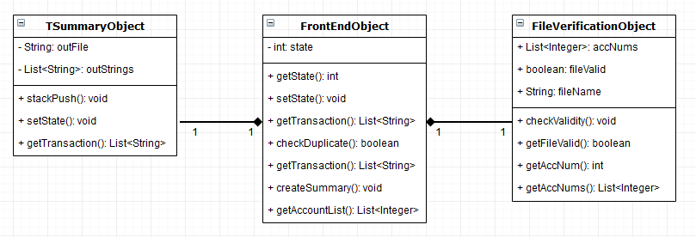

Exception Hierarchy:

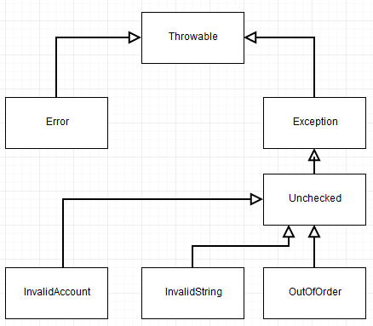

Transaction Object Hierarchy:

